Smart Factory Telemetry Data Architecture
Real-Time AWS Streaming Pipeline — End-to-End Design

Executive Summary

This document describes the end-to-end technical architecture of the Smart Factory Telemetry Data Pipeline, built entirely on Amazon Web Services (AWS). The pipeline is designed to continuously capture real-time telemetry from factory floor machinery and route that data through two parallel processing tracks:

- A Speed Layer (Hot Path) that delivers sub-second operational insights to live web dashboards via Amazon DynamoDB.
- A Batch Layer (Cold Path) that archives immutable, clean telemetry data to Amazon S3 for long-term BI reporting and ad-hoc SQL analytics via Amazon Athena

The system is designed to be fault-tolerant, automatically isolating malformed and corrupt records from the clean data lake, ensuring engineers and analysts always work with verified, high-quality data.

This pipeline covers the full journey of factory telemetry data from generation to consumption:
- Data Sources: Simulated Python telemetry generator (ingest.py) mimicking CNC and Conveyor sensor payloads.
- Processing: AWS Lambda (routing), Amazon Managed Apache Flink (stateful stream processing).
- Storage: Amazon S3 (data lake), Amazon DynamoDB (operational store).
- Analytics: AWS Glue Crawler + Data Catalog, Amazon Athena.
- Resilience: Amazon SQS Dead Letter Queue for corrupt record isolation.

2. High-Level Architecture Pattern

This pipeline implements the industry-standard Lambda Architecture pattern. All data enters through a single, unified front door — the Amazon Kinesis Data Stream — which acts as the central message broker and decoupler between data producers and downstream consumers.

Once ingested by Kinesis, the data bifurcates into two parallel processing layers:

Speed Layer (Hot Path) | Batch Layer (Cold Path)
Low latency, stateful stream processing | Durable, immutable historical data lake
Amazon Managed Apache Flink | AWS Lambda + Kinesis Firehose
1-min tumbling + 5-min hopping windows | Dynamic S3 Hive-style partitioning
Sink: Amazon DynamoDB (upsert, 60s) | Sink: Amazon S3 + Athena SQL
Use case: Live dashboard, alerting | Use case: BI reporting, trend analysis

The diagram below illustrates the full data flow from factory floor sensors to all downstream AWS sinks.
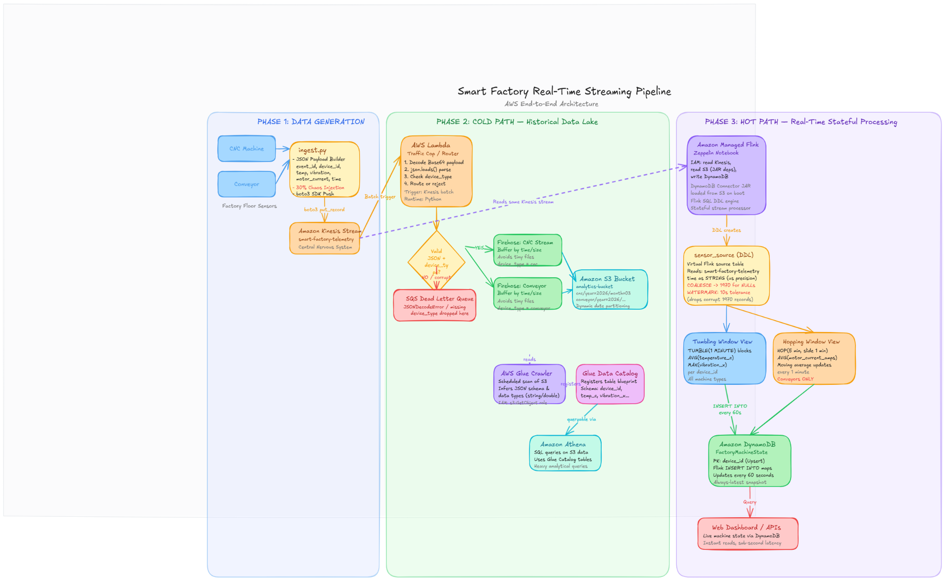

3. Data Ingestion Layer

The data source for this pipeline is a Python-based telemetry simulator (ingest.py) that runs continuously to model the data streams that real factory PLCs and SCADA systems would produce. To stress-test the pipeline's resilience, the generator intentionally injects bad records which include includes malformed JSON strings, missing required fields (e.g., dropping event_time or device_type), and truncated payloads.

The Python generator uses the AWS boto3 SDK pushing each serialized JSON payload into the Amazon Kinesis Data Stream Both the Cold Path (Lambda) and the Hot Path (Flink) consume from the same stream independently and simultaneously , ensuring neither path is aware of or dependent on the other.

4. The Speed Layer (Hot Path)

Processing Engine: It reads the same Kinesis stream as the Cold Path and uses Apache Flink's streaming SQL engine to compute continuous, rolling machine metrics that power the live operational dashboard.
- Runtime: Apache Flink (latest stable), running as a Zeppelin Notebook for interactive SQL-based development.
- S3 Dependency: The official Flink SQL DynamoDB Connector JAR is stored in the S3 bucket and loaded into Flink's classpath at notebook startup, enabling native DynamoDB sink support.
Windowing Strategies:
- Tumbling Window: A strict, non-overlapping 1-minute Tumbling Window (TUMBLE) continuously slices the incoming stream into discrete 60-second blocks. For every closed window, it emits AVG(temperature_c) the average operating temperature across all events for each device_id, and MAX(vibration_x) — the peak vibration reading within the window, critical for detecting mechanical anomalies.
- Hopping Window: A 5-minute Hopping Window (HOP) is applied exclusively to Conveyor telemetry. Unlike the tumbling window, the hopping window slides by 1 minute, producing a new 5-minute moving average of motor_current_amps every 60 seconds.
Operational Datastore (Amazon DynamoDB): Aggregated metrics from both window views are written to the DynamoDB table FactoryMachineState using an INSERT INTO Flink SQL statement mapped to the DynamoDB connector.

5. The Batch Layer (Cold Path)

The Cold Path is responsible for capturing every valid telemetry record, cleaning it, and writing it into a durable, immutable data lake on Amazon S3. This layer is the foundation for all long-term historical analysis, BI reporting.
- Stream Routing (AWS Lambda): An AWS Lambda function (Python runtime) is configured as a direct Kinesis trigger. Each time a batch of records accumulates in the stream, Kinesis invokes Lambda with the batch as its event payload. The function performs the following steps:
  - Decode: Each Kinesis record's data payload is Base64-decoded to recover the raw JSON string.
  - Parse: json.loads() is called on the decoded string.
  - Validate: If parsing succeeds, the function checks for the presence of the device_type key the routing discriminator. A missing device_type makes the record unroutable.
  - Route: Records that pass both checks are forwarded to the appropriate Kinesis Firehose delivery stream based on device_type value. Records that fail either check are dropped to the SQS Dead Letter Queue.

- Delivery & Buffering (Amazon Kinesis Data Firehose): Kinesis Firehose delivery streams are provisioned, one for each machine type. Firehose provides intelligent buffering between Lambda and S3:
  - Buffering prevents the creation of millions of tiny individual files in S3 (a "small files problem" that severely degrades Athena query performance).
  - Records are grouped until either a time threshold (e.g., 60 seconds) or a file size threshold (e.g., 5 MB) is reached, whichever comes first.
  - The buffered batch is then written as a single JSON file to the target S3 prefix.

- The Data Lake (Amazon S3): Firehose writes buffered files into the central S3 data lake bucket (smart-factory-analytics-bucket). The bucket uses dynamic Hive-style partitioning, organizing data into a folder hierarchy that maps directly to Athena partition pruning.

- Data Catalog & Analytics (AWS Glue & Athena): An AWS Glue Crawler is scheduled to run periodically against the S3 bucket. The Crawler is granted an IAM role with s3:GetObject permissions to open and inspect the buffered JSON files. It automatically infers the schema — field names and data types (strings, doubles) — and registers this blueprint as formal table definitions in the AWS Glue Data Catalog. Once the Glue Catalog tables are registered, analysts and BI tools can query the raw S3 JSON files using standard ANSI SQL through Amazon Athena.

- Databricks Lakehouse Integration (Medallion Architecture)
To expand the analytical capabilities of the Cold Path, the pipeline integrates with Databricks to process the S3 data lake into a structured Medallion Architecture (Bronze, Silver, Gold).
- Ingestion & State Management (Auto Loader): Databricks Auto Loader is utilized to process newly incoming data. Auto Loader incrementally and idempotently ingests the raw JSON files dumped by AWS Firehose in the S3 data lake into Bronze Delta tables.
- Storage Abstraction (Unity Catalog): The Bronze layer utilizes external stages to refer to the data in AWS S3. These external locations are securely managed via Databricks Unity Catalog, ensuring governed access without hardcoded AWS keys.
- Change Data Capture (CDF): To optimize downstream processing, Change Data Capture (CDC) is implemented by enabling the Change Data Feed for the Delta tables.
- Pipeline Orchestration (Databricks Workflows): Databricks Workflows orchestrate the workflow across the three architectural layers.
  - Bronze Layer: Ingests raw data incrementally via Auto Loader.
  - Silver Layer: Reads the Bronze data, performs strict deduplication (via idempotent MERGE operations), parses timestamps, and enforces data quality checks. Valid records are stored in Silver Delta tables.
  - Gold Layer: Reads the Silver CDF to efficiently process only net-new records. It computes business-level aggregations (e.g., hourly machine health summaries) for downstream BI tools.

6. Resilience & Error Handling

Multiple independent layers of error handling ensure that corrupt, malformed, or late data never contaminates the clean data lake or crashes the streaming engine.
- Dead Letter Queue (SQS DLQ): The SQS Dead Letter Queue is the data lake's immune system. By routing all invalid records to the DLQ before they ever reach Firehose or S3, the pipeline guarantees that only structurally valid, routable records enter the permanent data lake.
- Flink Watermark & COALESCE: The Flink Watermark and COALESCE pattern work together as a two-stage filter specifically designed to handle the 30% corrupt records injected by the telemetry generator. The COALESCE ensures Flink never encounters a null timestamp that would cause a job exception, while the Watermark removes records from all window aggregations.

7. Security & IAM Configuration

Every AWS service in this pipeline operates under an IAM role scoped to the minimum permissions required for its specific function. The permissions include:
- Read-only from Kinesis; write-only to SQS DLQ and Firehose streams.
- The Flink Studio application is granted a least-privilege IAM role with explicit permissions to: read from the Kinesis stream, read from S3 (for loading the DynamoDB connector JAR), and write to the DynamoDB FactoryMachineState table.
- Read-only S3 access scoped to the analytics bucket; write to Glue Catalog only.
- Write-only to the specific S3 prefix. Cannot read, delete, or access other buckets.

8. Future Enhancements

- Real-Time Alerting: Add a secondary Flink output sink that pushes anomaly events (e.g., motor_current_amps exceeding safe thresholds) to a secondary Kinesis stream, triggering an AWS Lambda function to format and dispatch notifications via Amazon SNS.
- Observability: Setup CloudWatch Alerts to monitor pipeline health.
- Cost Optimization: Setup S3 lifecycle policies or use Intelligent tiering mechanism to move old data to archive to save on storage costs. If storing data in warehouses apply partitioning, sorting and compression techniques to save on query scan costs based on the data bytes scanned.
- Advanced Governance: Use of Lake formation to maintain RBAC and implement RLS and CLS on specific tables within database.

